Safety In Science and Technology
Name:___________________________________ Date:____________ Class:___
Report ALL accidents to the teacher…no matter how minor!
Location of Safety Equipment: describe the location in the science class of the following safety items
Safety goggles__________________________________________________________________
eye wash station________________________________________________________________
first aid kit_____________________________________________________________________
fire blankets____________________________________________________________________
fire extinguisher_________________________________________________________________
When Working with Chemicals: always stand, wear protective eye wear, never wear open toed shoes, tie back long hair, tuck in loose clothing, remove jewelry, never taste chemicals, never directly smell chemicals (use the waving technique), always use test tube racks, call teacher if you spill chemical on your skin (dilute with cold water for 10 minutes), call teacher if glass breaks or chemicals spill...do not clean up yourself.
When Working with Heat: never heat a test tube with rubber stopper, always heat a test tube pointed AWAY from you, never touch glass directly to the hotplate, make sure hot plate is not in contact with water on counter, never touch a beaker/flask/test tube if not sure if hot or not…use leather gloves,
When Working with Tools: always use a clamped down mitre box when using a saw, always clamp material to be drilled (make sure there is a protective piece of wood under the material being drilled), use glue gun in a low-traffic area. Glue gun tips are hot and can burn you, be careful with hot glue, do not directly touch…run under cold water for 10 minutes if hot glue touches your skin, keep hands and tools away from wet sockets, report damaged equipment to teacher.
Safety Conventions: Caution symbols are used to identify potential hazards when using chemicals at home or at school. They are divided into two categories…WHMIS and HHPS (see over)

Hazardous Household Product Symbols (HHPS) are for products bought at a store and intended for use in the home. The symbol indicates exactly what the hazard is and to what degree of danger.

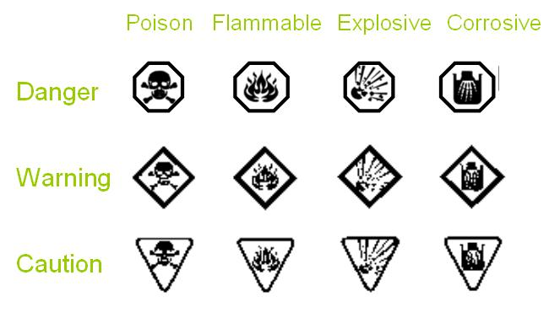 Workplace Hazardous Materials Information System (WHMIS) do the same as HHPS but are international symbols used in workplaces and schools.
